**CHAPTER IV**

**RESULTS AND DISCUSSION**

The main purpose of this chapter is to provide the presentation, analysis and interpretation of data that has been categorized in accordance with the sequence of questions enumerated in the first chapter. All of the data collected from the evaluators were presented in tabular form with corresponding discussion and explanation of the findings obtained.

**Part I. Development of VirtualShrine: An interactive museum website for Casa Real Shrine**

Over time, museums continue to be forgotten by people, so some of them do not know about the importance of history. One of them is the Casa Real Shrine of Malolos. Because of the continuous advancement of modern technology, some of what can be seen in the museum can also be seen on the internet, the proponents have looked for a way so they introduced the “Virtual Shrine” a website that people can use to see what’s inside of the Casa Real Shrine and can book for their visit via online booking.

* 1. **Online Booking Reservation**

**Booking Consent Form**

Figure 59 displays the Booking Consent Form page. This page contains a statement regarding the collection of the visitor’s booking information.

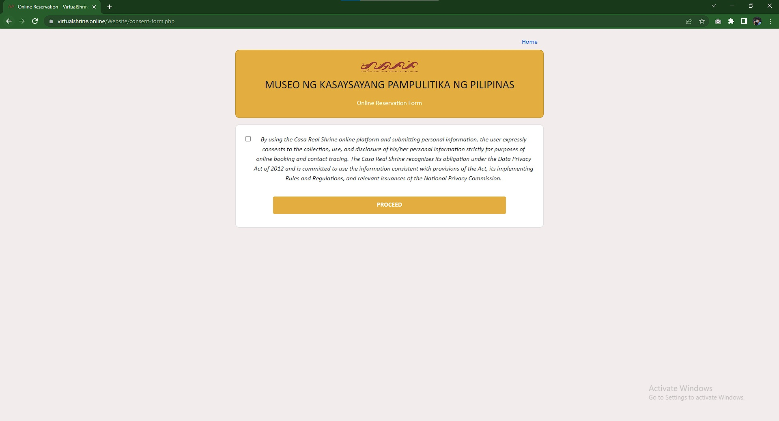

**Figure 59.** **Booking Consent Form**

This page is required because the visitor will have to provide their personal information. By checking the consent for checkbox, the visitor consents the collection of their information.

**Booking Form**

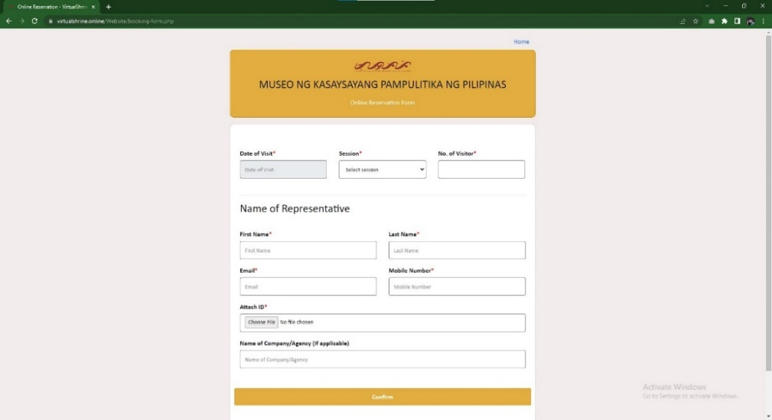 Figure 60 displays the Booking form which allows visitors to make a reservation for a museum visit. The form requires the visitor to provide necessary information for the booking process.

**Figure 60.** **Booking Form**

This form is a necessary part of the process to ensure that the visitor's reservation is valid and allows the museum management to keep track of the number of visitors they have at any given time. The information gathered from this form is essential for the business to manage their guest flow and ensure everyone has an enjoyable experience.

**Booking Submitted Confirmation Page**

Figure 61 displays the confirmation page that the visitor’s booking is submitted successfully and reviewed by the administrator if all the details that the visitor provided are valid.

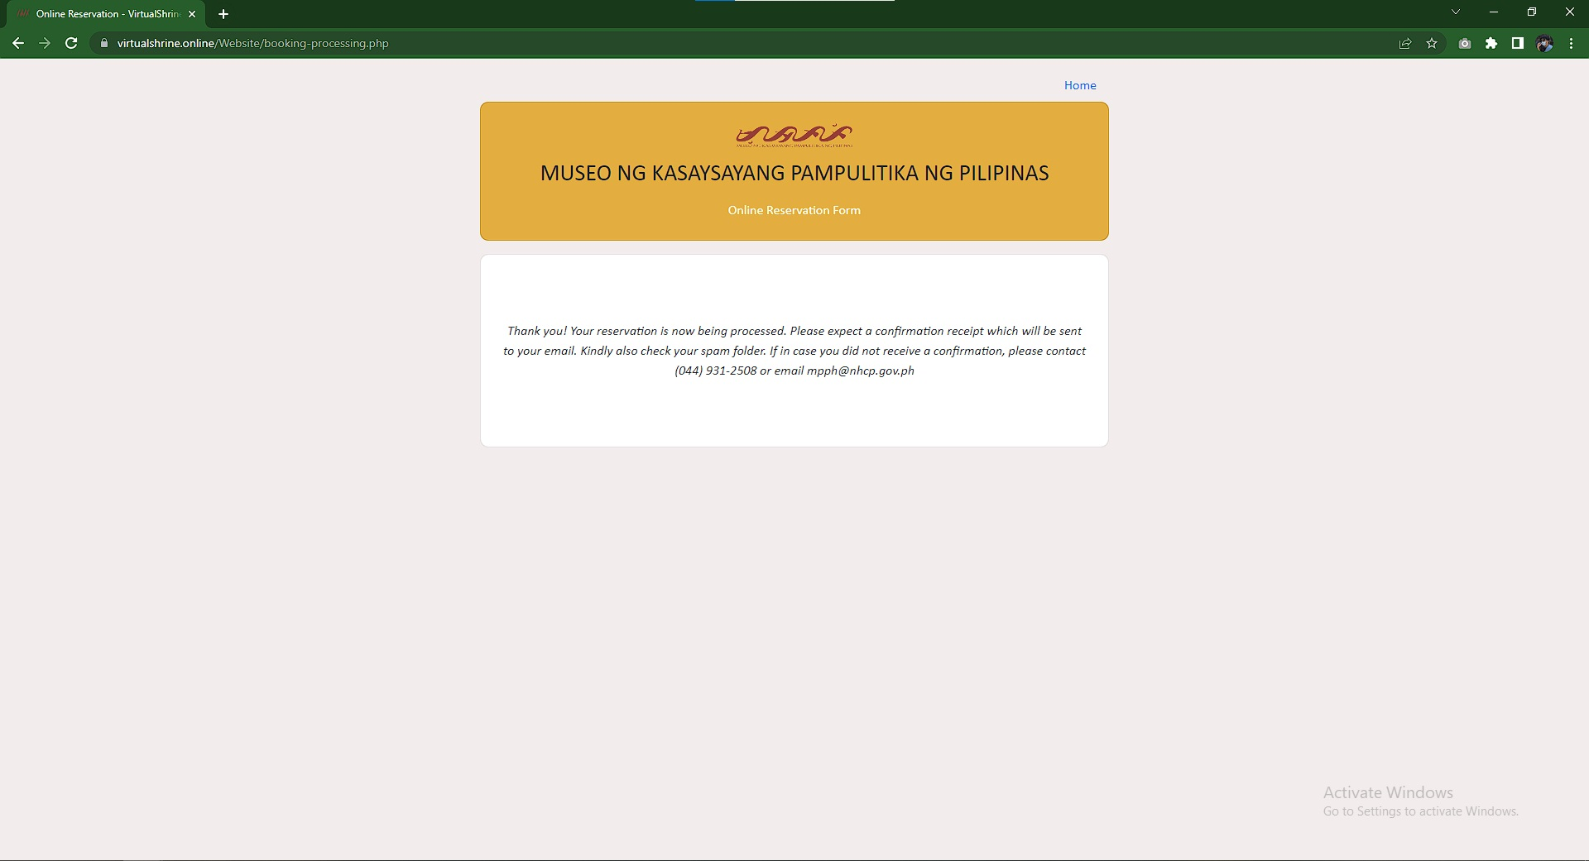

**Figure 61.** **Booking Submitted Confirmation Page**

* 1. **Virtual Museum Tour**

**Access to the Virtual Tour Page**

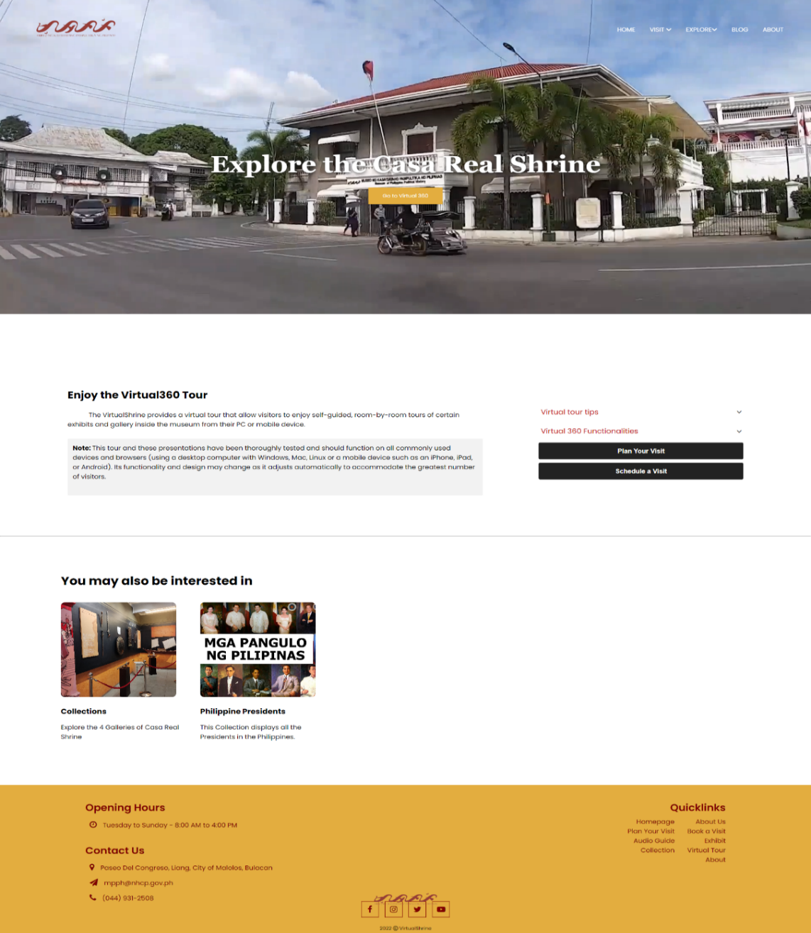Figure 62 displays the access page to the website's Virtual Tour feature. The website allows visitors to explore the museum virtually through a 360-degree viewing experience, enabling them to get an immersive, interactive experience of the museum from the comfort of their own home.

**Figure 62:** **Access to the Virtual Tour Page**

Figure 62 shows the page users must access before exploring the virtual tour, which is displayed in subsequent figures. By providing this feature, the website allows visitors to get a better understanding of the museum's layout and features before deciding if they would like to visit in person.

**Casa Real Shrine Virtual 360**

Figure 63 displays the landing page when the user opens the virtual tour.

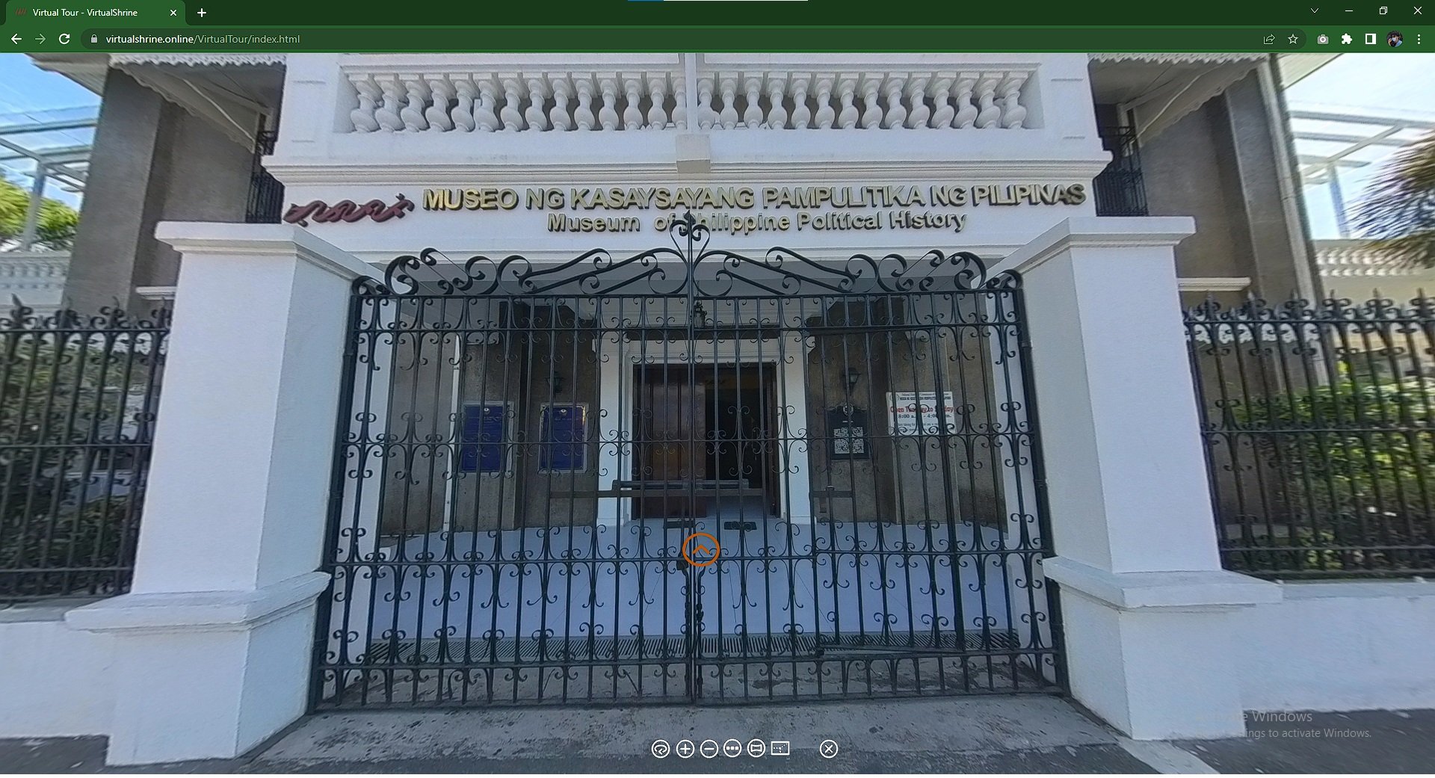

**Figure 63.** **Casa Real Shrine Virtual 360**

The yellow Door icon is the hotspot for the user to access inside the museum. At the bottom part of, the screen displays the controller for the virtual tour. This helps the user to familiarize themselves with the virtual 360 and navigate it easily.

**Casa Real Shrine Lobby Virtual 360**

Figure 64 displays the first room of the museum after entering the building. The Visitor can swipe from left and right to view the surroundings of the room and to interact with other hotspots they can use for other information of the museum.

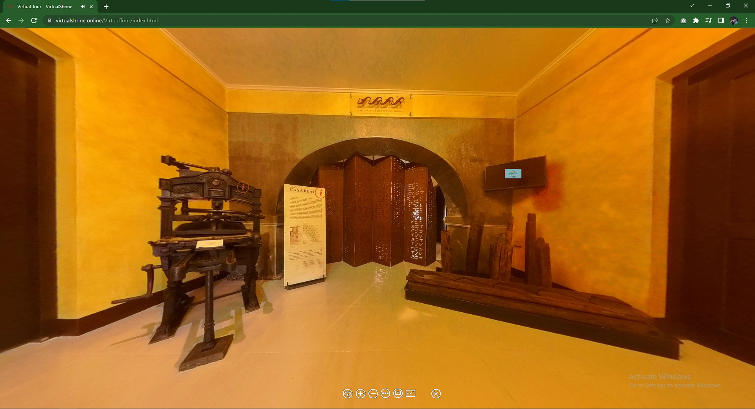

**Figure 64.** **Casa Real Shrine Lobby Virtual 360**

The hotspot where the visitor can use to interact with the display in the museum. If the visitor presses the hotspot, the system will display a pop-up with the definition of the display.

* 1. **Gallery Collections**

**Galleries**

Figure 65 displays the 4 galleries of the museum. Each card corresponds to a different gallery collection page, including Kaginhawaan (Prosperity), Paniniil (Oppression), Pagbabagong-puri (Revolution), and Pagbuo ng bayan (Making the Nation).

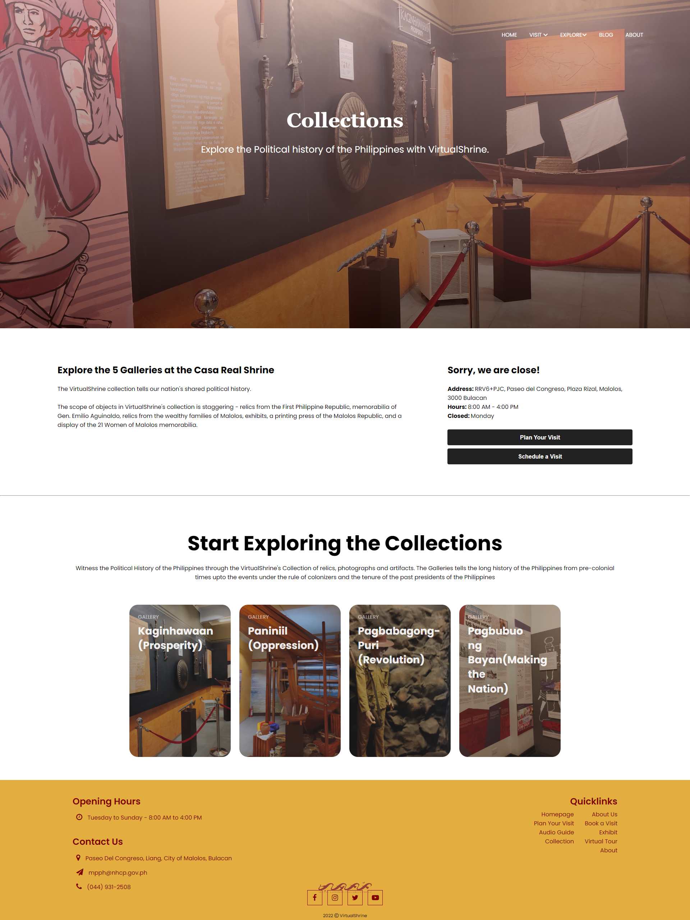

**Figure 65. Galleries**

It is designed to be user-friendly, allowing visitors to easily navigate through the different galleries. The page is divided into four sections, each containing an image hyperlink that leads to a collection page. Each collection page contains detailed descriptions of the items in that gallery, as well as images and videos to further illustrate the content. Additionally, the page includes an interactive map of the museum, allowing visitors to explore the different galleries in an immersive and engaging manner.

**Galleries Collections**

Figure 66 displays the gallery Collections page, which provides visitors with an overview of the various displays or artifacts found inside the gallery.

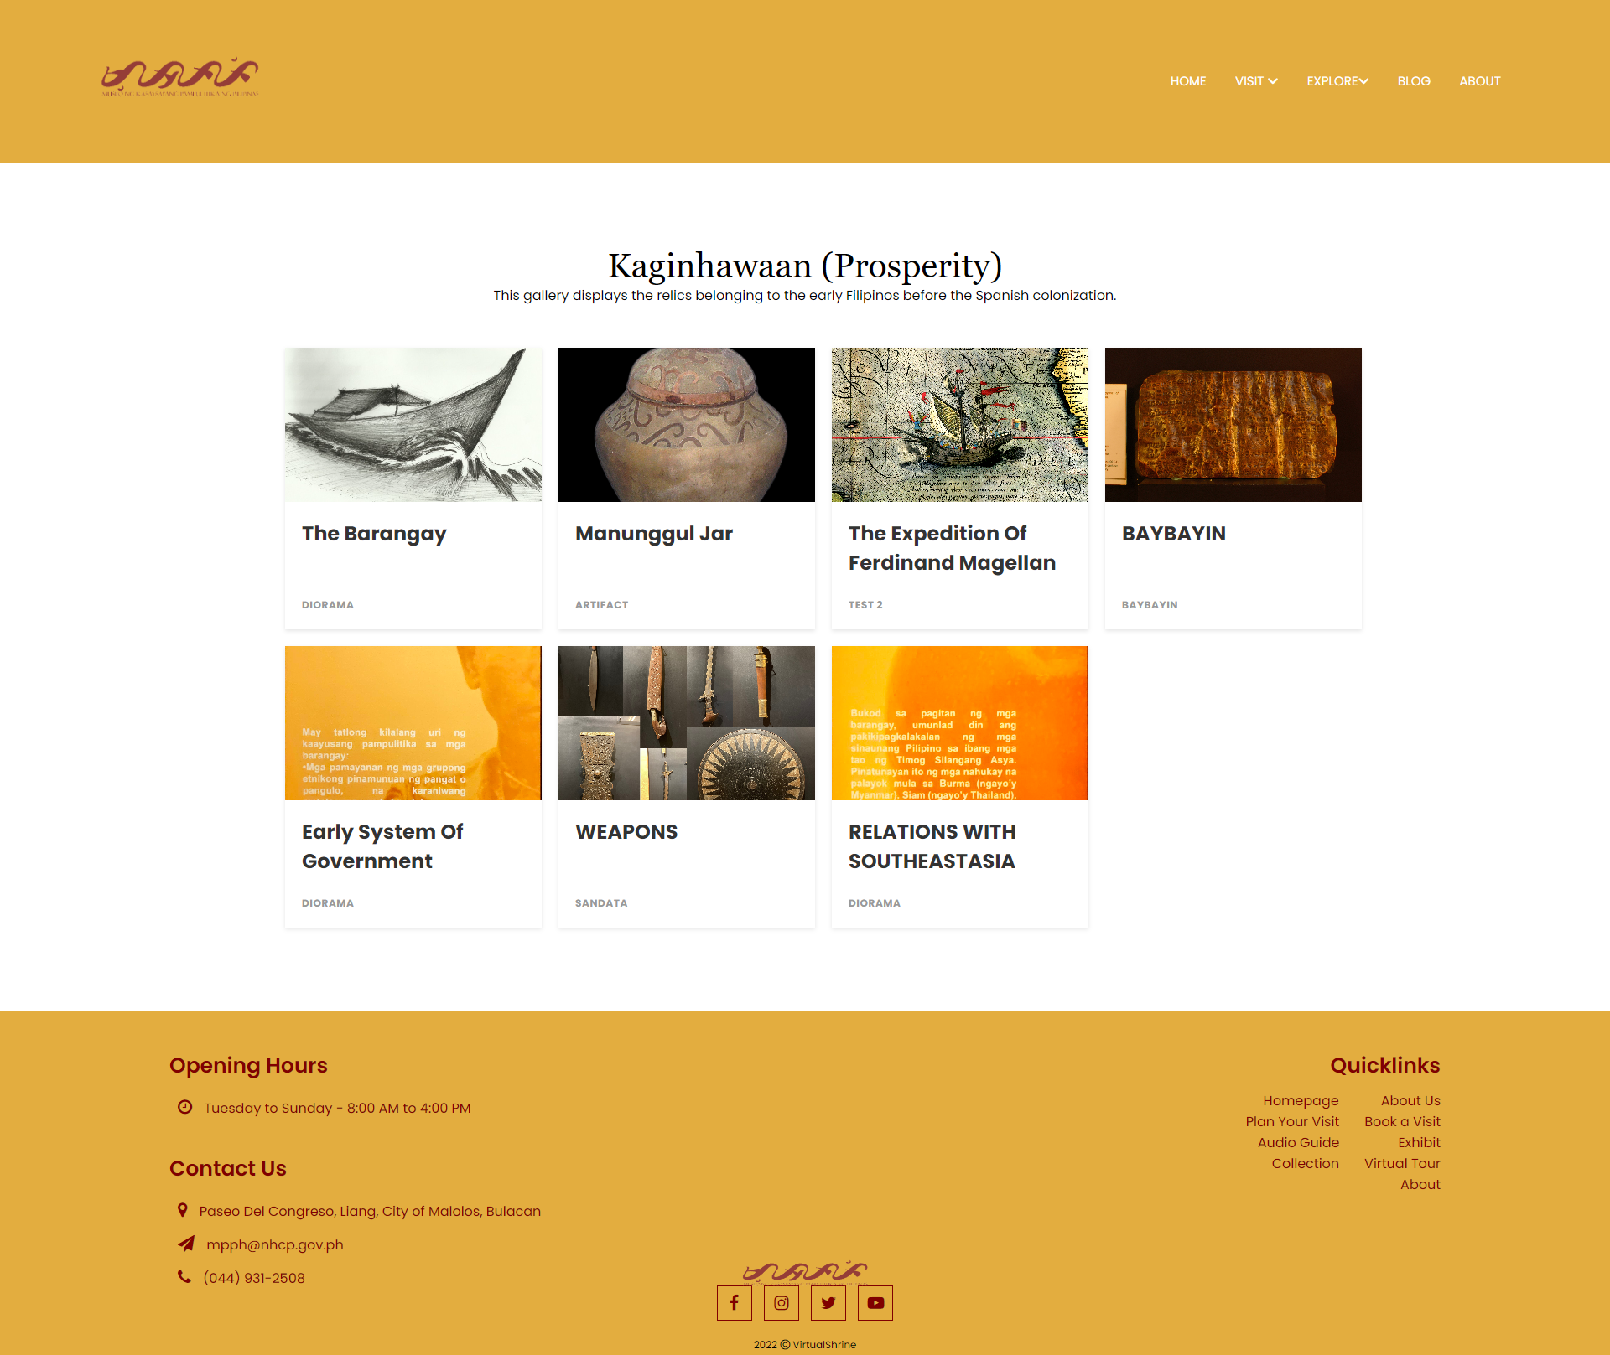

**Figure 66.** **Galleries Collections**

It is designed to provide viewers with an overview of the various displays and collections available within the gallery. The page features a grid-style layout with each collection represented by a thumbnail image. The Gallery Collections page is designed to give users an overview of the collections and displays offered within the gallery, and to provide easy access to further information.

**Display Description**

Figure 67 is a website page that displays information about a particular artifact. Visitors can view the picture and description of the artifact, as well as download the image.

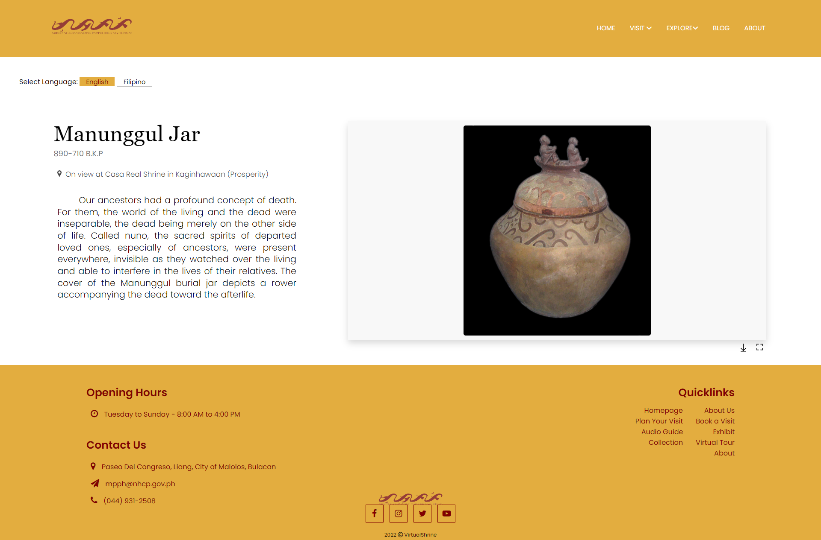

**Figure 67.** **Display Description**

This page is designed to provide visitors with an easy way to access information about the artifact and to conveniently obtain a copy of it. Additionally, the page also provides visitors with the option to choose the language for the description. This interactive website page allows visitors to gain a better understanding of the artifact and its history. The page is designed to be user-friendly and intuitive, with an easy-to-navigate layout. The page includes a clear picture of the artifact and a concise description that is informative and engaging.

**1.4 User Assisting Features**

**Plan Your Visit Page**

Figure 68 displays the general information regarding the operation of Casa Real Shrine such as the operation time and day, and Health and Safety Guidelines that is being implemented in the museum.

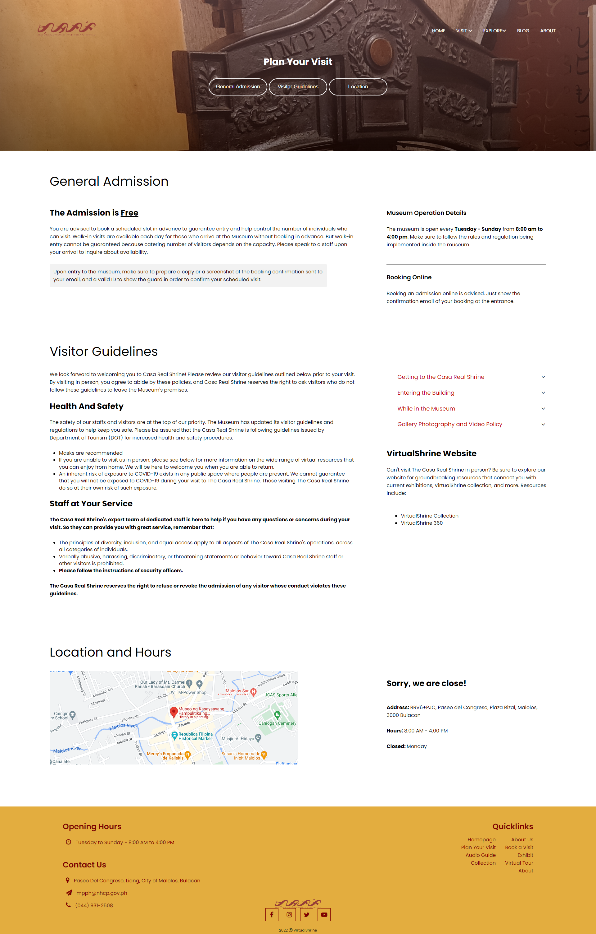

**Figure 68.** **Plan Your Visit Page**

The website page is designed to make visitors aware of the protocols and restrictions in place to ensure their safety during their visit. It is organized in a clear and straightforward manner, allowing visitors to quickly find the information they need.

**Audio Guide**

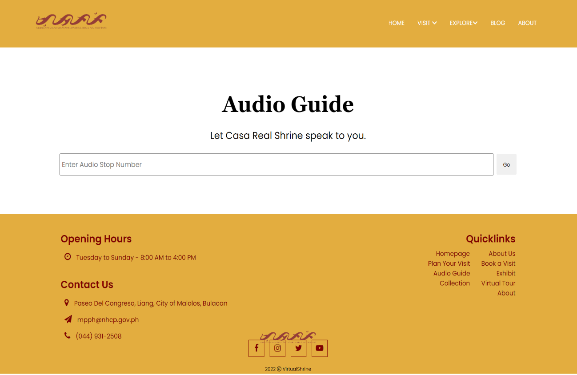 The audio guide page on Figure 69 is a page that allows users to gain access to audio guides for each display.

**Figure 69.** **Audio Guide**

The page is designed with a textbox where the user can input the audio stop number. The audio guide page is a useful resource for visitors to learn more about the different displays without having to read text, since they can hear all the relevant information in an audio format. The page is designed in a simple and straightforward manner, with a textbox as the focus, so that visitors can gain access to the audio guides quickly and easily.

**Part II. To design and develop a Management System**

In order to better manage the website content and allow admins to upload and modify the contents seen on the website, a Management System was developed.

**2.1 Manage User Admins**

**User Management**

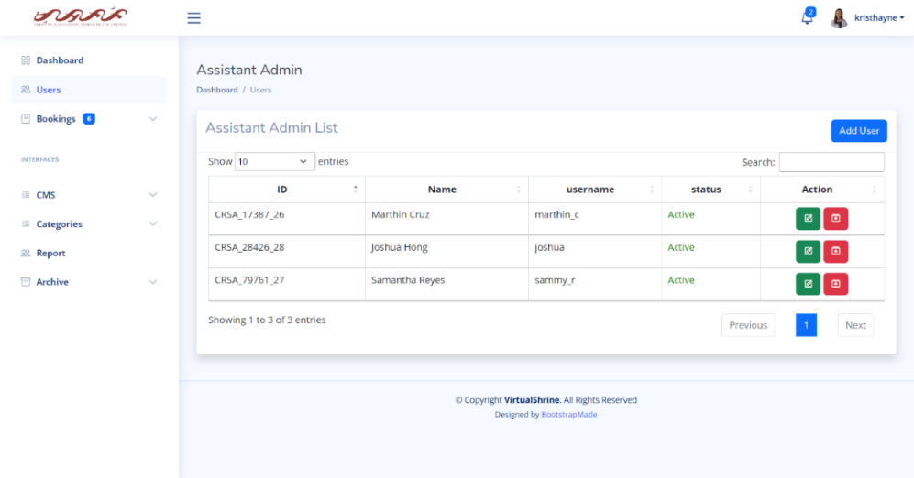 Figure 70 shows the user management panel. This is where the super admin can be able to view all the assistant admins.

**Figure 70.** **User Management**

The panel is designed to provide a clear and concise overview of the users. It displays a table containing their ID, Name, Username and Status, as well as two action buttons, edit and archive, to allow the super admin to update the user's information and remove them if necessary. Additionally, the page is designed with an intuitive interface, allowing the super admin to easily navigate through the user information and make any necessary changes.

**Edit User Information**

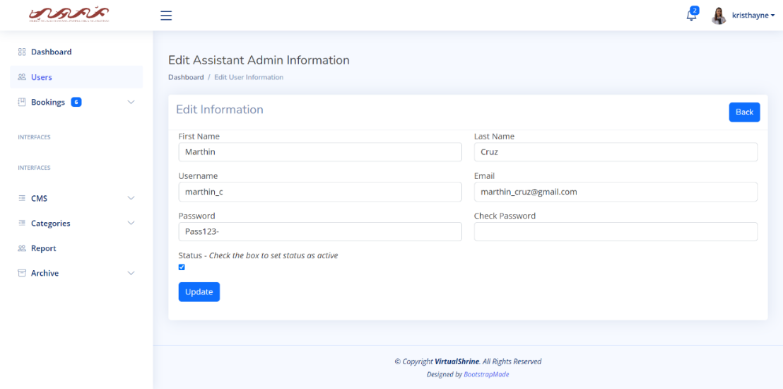Figure 71 displays the Edit User Information form, which is a page designed so that the Super Admin can make desired modifications or changes to the user information.

**Figure 71.** **Edit** **User Information**

The page is designed with a simple and user-friendly interface, making it easy and accessible for the Super Admin to make any necessary changes to the user information. This page is essential for the Super Admin as it allows them to make any changes quickly and easily, they need to the user information.

**Add New User**

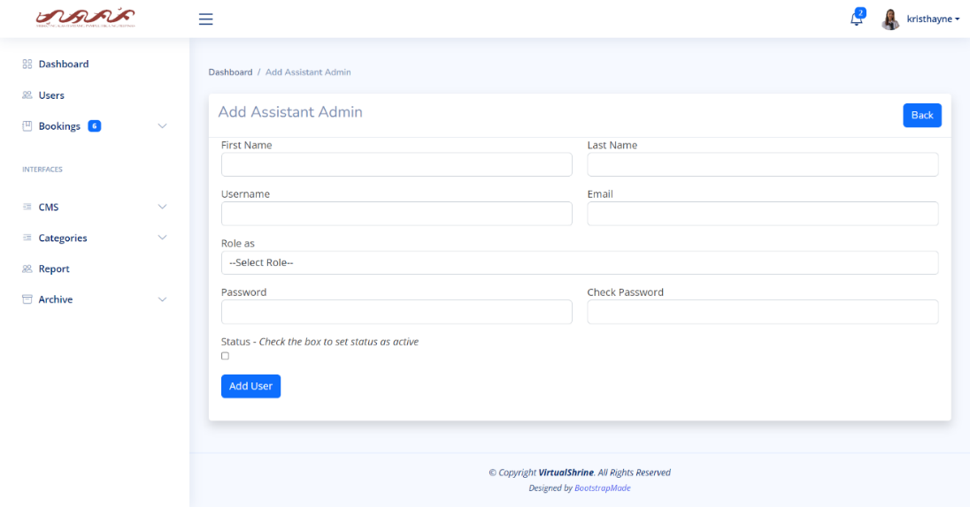Figure 72 displays the Add User Information form, a web page designed for Super Admins to add the details of any new admins on the system.

**Figure 72.** **Add New User**

This page is designed with a simple yet effective layout. By providing a simple and straightforward design, this page allows Super Admins to add any new admins quickly and easily to the system.

**2.2 Accept and Reject Visitor Booking**

**View all Pending Booking**

In Figure 73, a table displays the pending bookings, including the Booking ID, Name of Visitor, Date of Visit, Number of Visitors, and status of the booking. For additional information, the admin can click “View Details”.

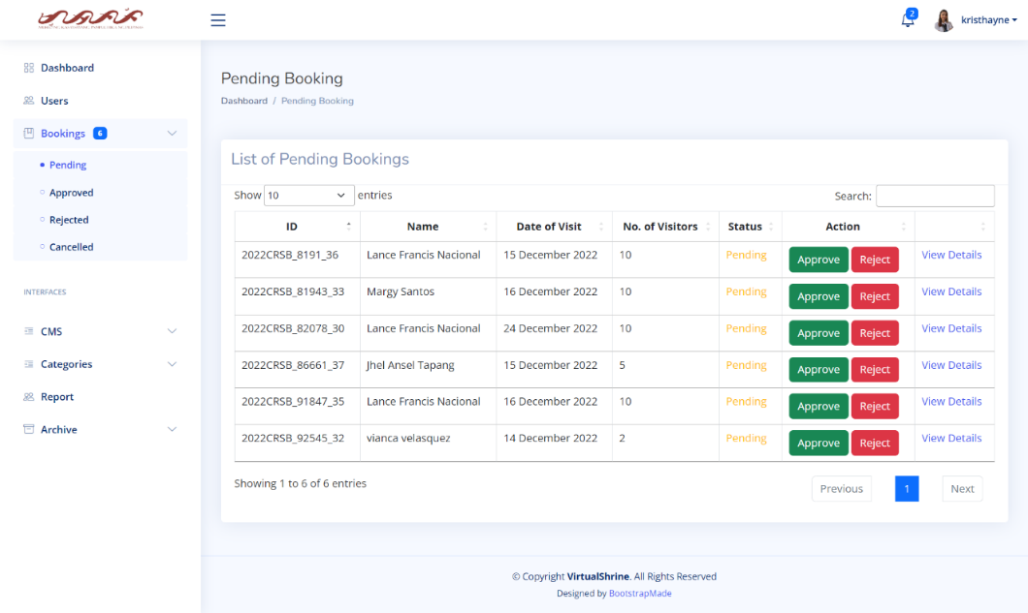

**Figure 73.** **View all Pending Booking**

**View More booking details**

Figure 74 displays the page where the complete booking information is displayed. This page displays the Booking ID, Name, Phone No., Email, Attached File, Date of Visit, and Number of Visitors. The admin can also perform an action on this page either to approve or reject the booking.

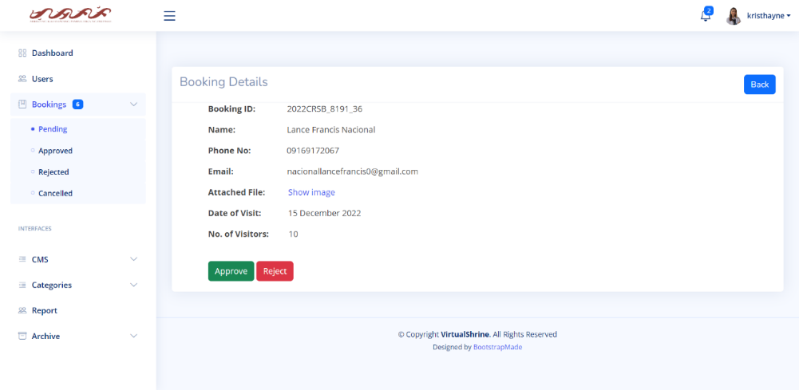

**Figure 74.** **View More booking details**

**View More booking details**

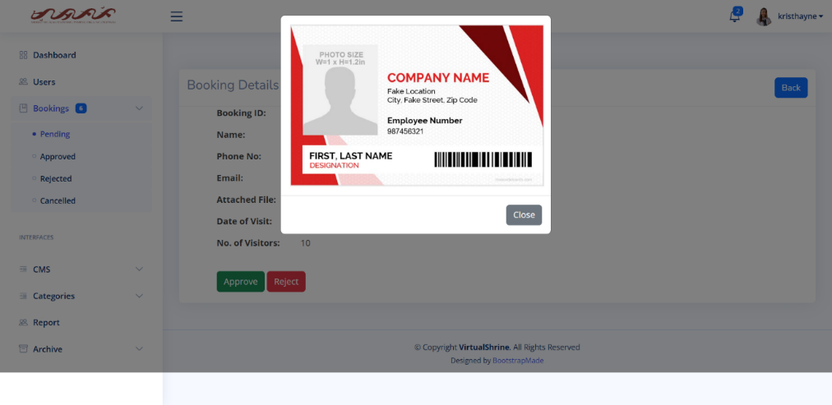Once the admin clicks the "show image" button, Figure 75 displays the page response. This feature is used to allow admins to verify the legitimacy of the attached ID.

**Figure 75.** **View More booking details**

**2.3 Upload Website Content**

This module is the CMS of the Management System. This allows admins to upload and modify website contents.

**2.3.1 Collections**

**Content Management System – Collections**

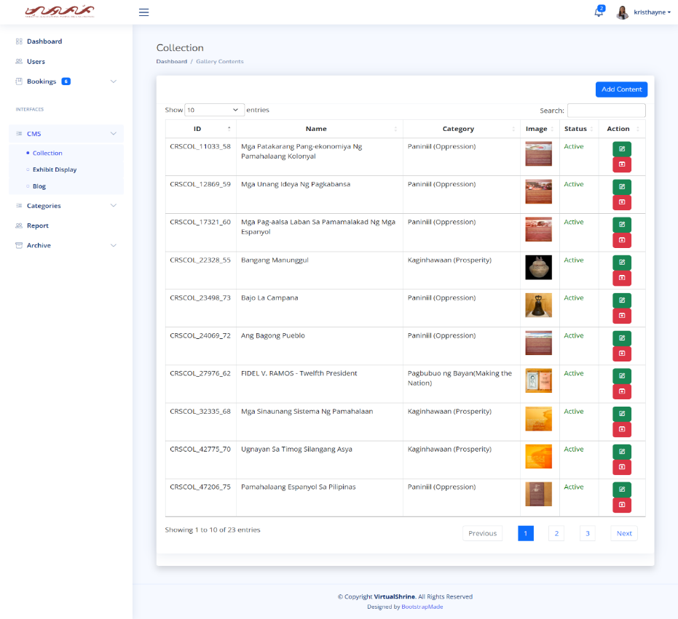In Figure 76, the Collection CMS is shown. It includes a table that provides information about the collection, such as its ID, title, the gallery it belongs to, a preview image, and its status. There are also action buttons for editing and archiving.

**Figure 76.** **Content Management System – Collections**

**Content Management System – Edit Collection Information**

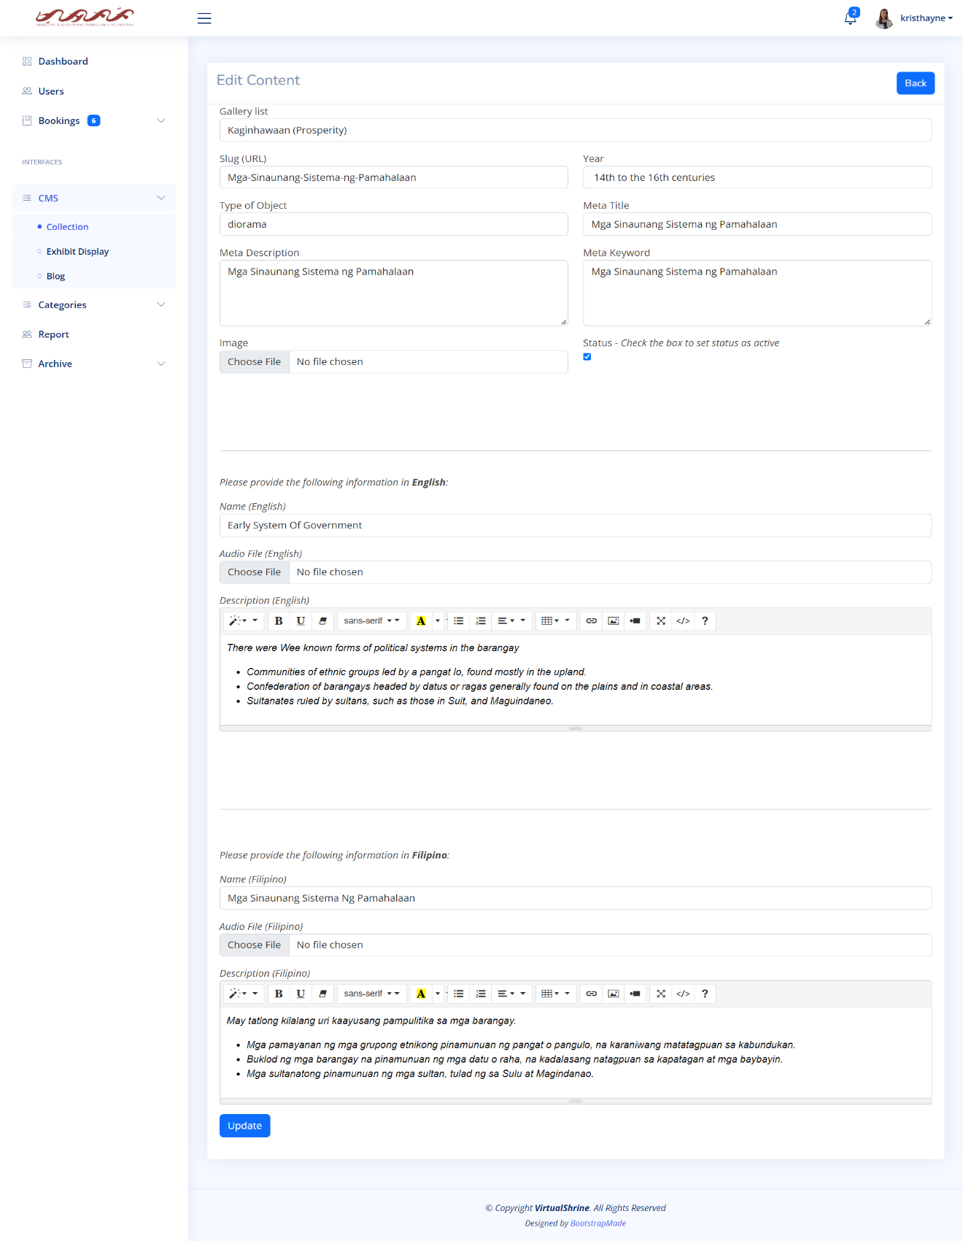As seen in Figure 77, the Edit Collection form gives admins the ability to edit the collection's information.

**Figure 77.** **Content Management System – Edit Collection Information**

**Content Management System – Add new Collection**

In Figure 78, the Add new Collection form is shown. This is where the admin can add new collection that can displayed on its respective gallery category on the website.

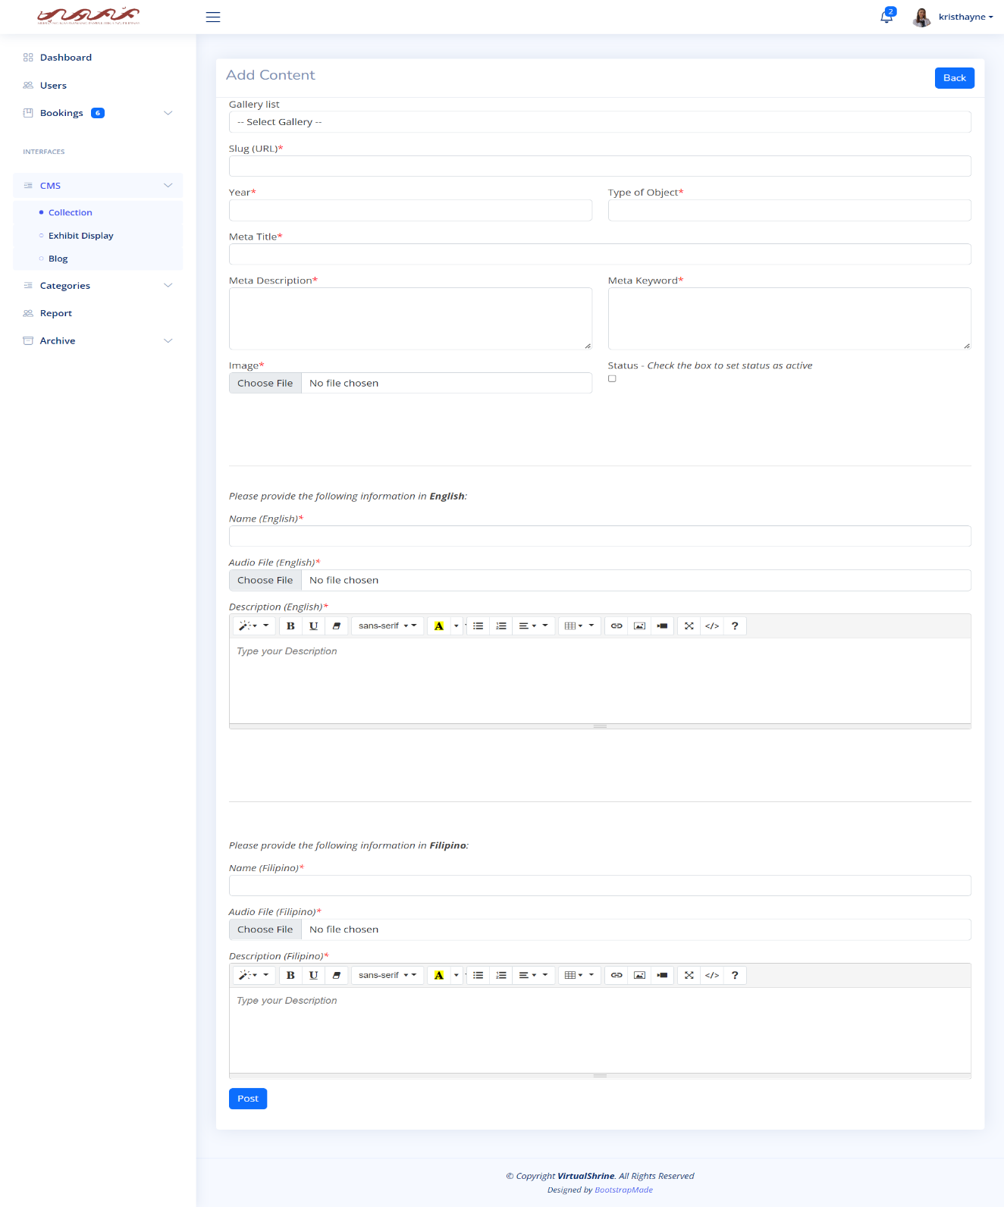

**Figure 78.** **Content Management System – Add new Collection**

Through this form, the admin can input the title and description of the collection, as well as the images to be featured in the gallery. This allows the admin to add new collections quickly and easily, making the website's gallery more dynamic and engaging.

**2.3.2 Exhibits**

**Content Management System – Exhibit Display**

Figure 79 displays the Exhibit Display Content Management System (CMS). This CMS provides a table that includes essential details about the Exhibit Display, such as its ID, Title or Name, the Exhibit it is associated with, a preview image, and its status.

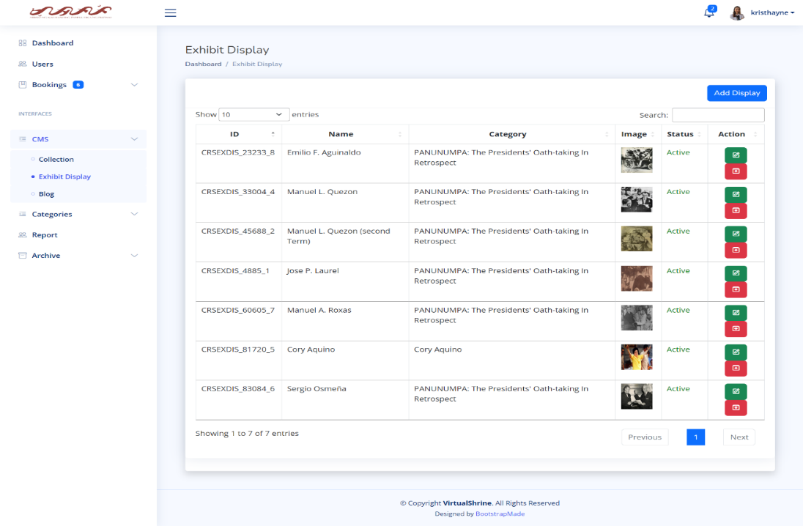

**Figure 79.** **Content Management System – Exhibit Display**

This panel provides action buttons for editing and archiving. The purpose of the Exhibit Display CMS is to allow administrators to easily access, edit, and manage all the Exhibits Displays. Through the CMS, users can quickly view the existing Exhibit Displays, add new ones, view, and modify existing ones, archive them, and more. This makes it easy to keep track of all the Exhibit Displays and ensure that they are updated and accurate.

**Content Management System – Add new Exhibit Display**

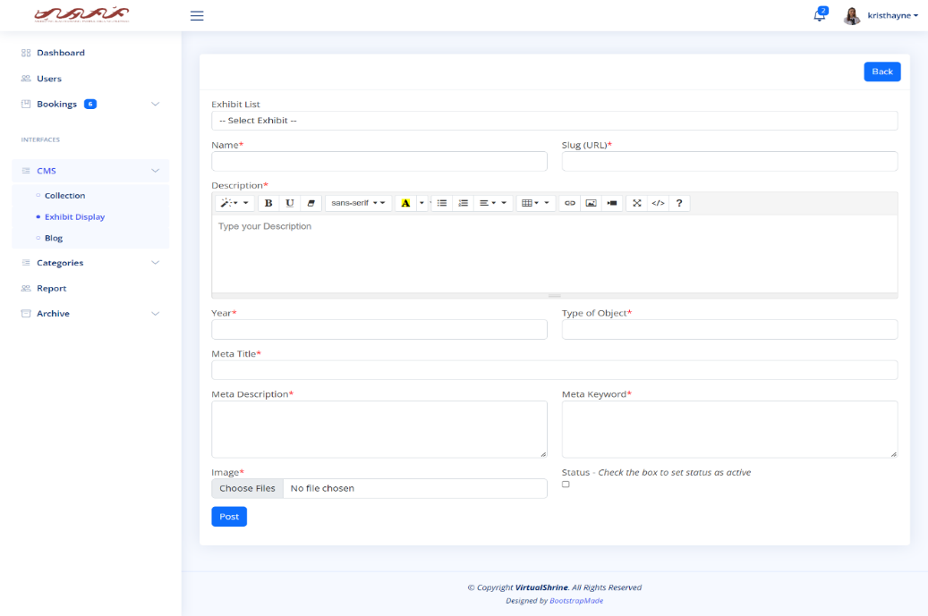In Figure 80, the Add new Exhibit Display form is shown. This is where the admin can add new Exhibit Display.

**Figure 80.** **Content Management System – Add new Exhibit Display**

The form includes fields for the name of the display, the type of display, and the description of the display. The purpose of the form is to provide a way for administrators to add new displays quickly and easily to an exhibit. This allows for more flexibility and customization of the exhibit, allowing for the creation of a truly unique and engaging experience.

**Content Management System – Edit Exhibit Display**

As seen in Figure 81, the Edit Exhibit display form gives admins the ability to edit the Exhibit display information.

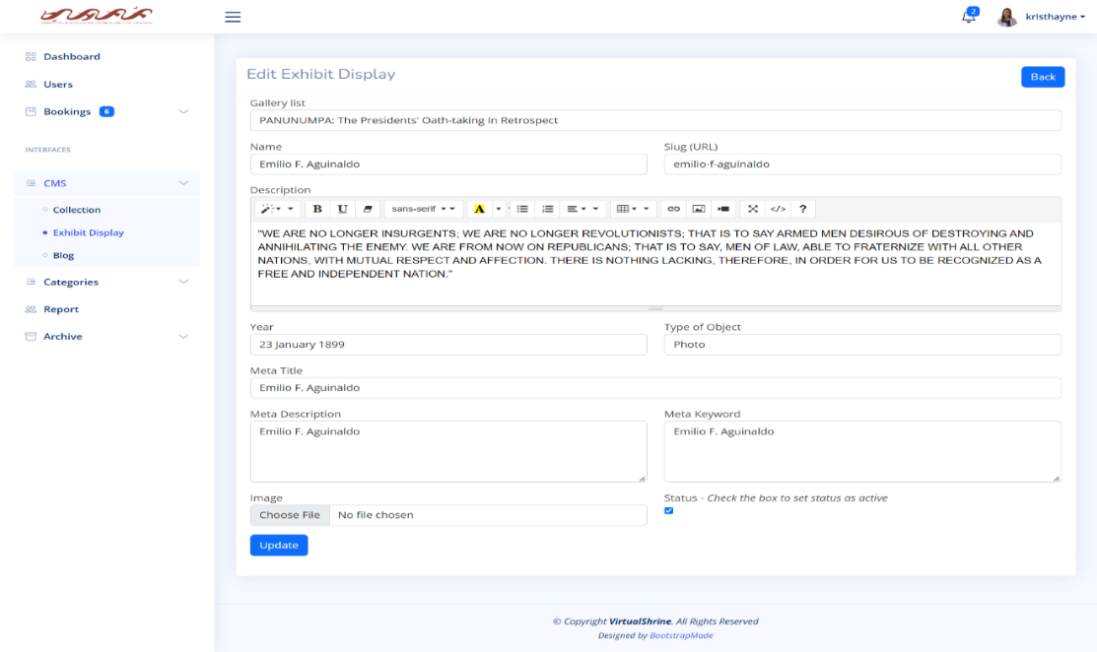

**Figure 81.** **Content Management System – Edit Exhibit Display**

**2.3.3 Blogs**

**Content Management System – Blog**

In Figure 82, the Blog CMS is shown. It includes a table that provides information about the Blog, such as its ID, Name, a preview image, and its status. There are also action buttons for editing and archiving.

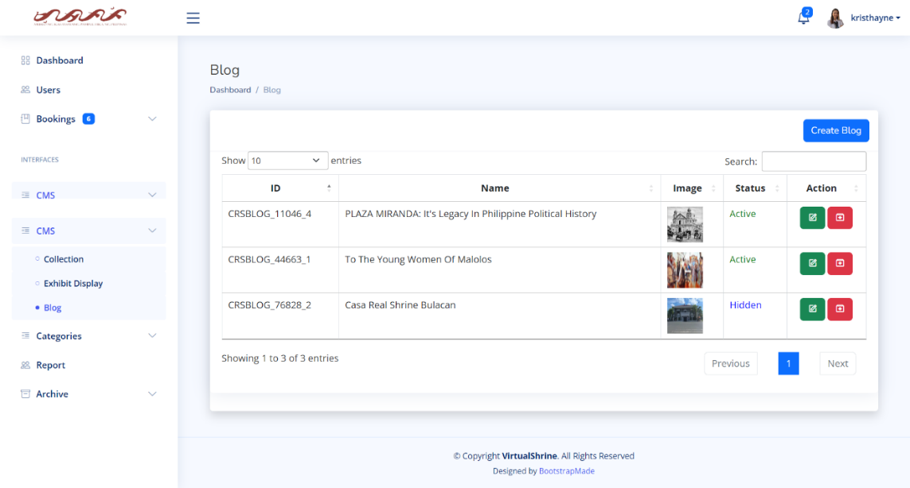

**Figure 82.** **Content Management System – Blog**

**Content Management System – Create a Blog Post**

In Figure 83, the Create a Blog form is shown. This is where the admin can add and upload new Blog posts.

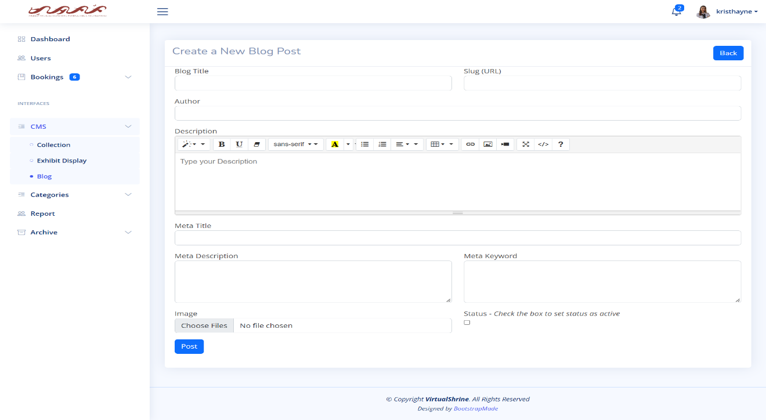

**Figure 83.** **Content Management System – Create a Blog Post**

**Content Management System – Edit**

As seen in Figure 84, the Edit Blog form gives admins the ability to edit the Blog information.

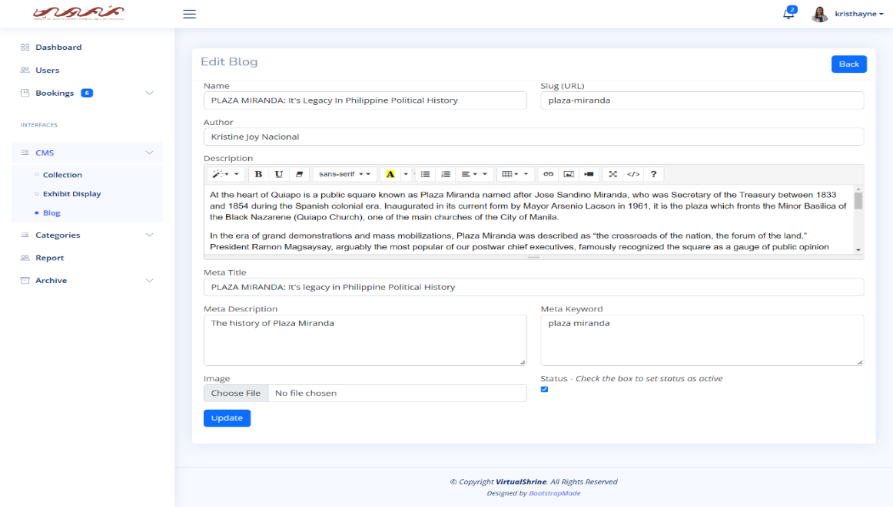

**Figure 84.** **Content Management System – Edit Blog**

**2.4 Generate and Print Admin Activity Record**

**Activity Report**

Figure 85 shows every activity like editing some of the website content or updating profile of the admin. It also includes the date when the data is changed.

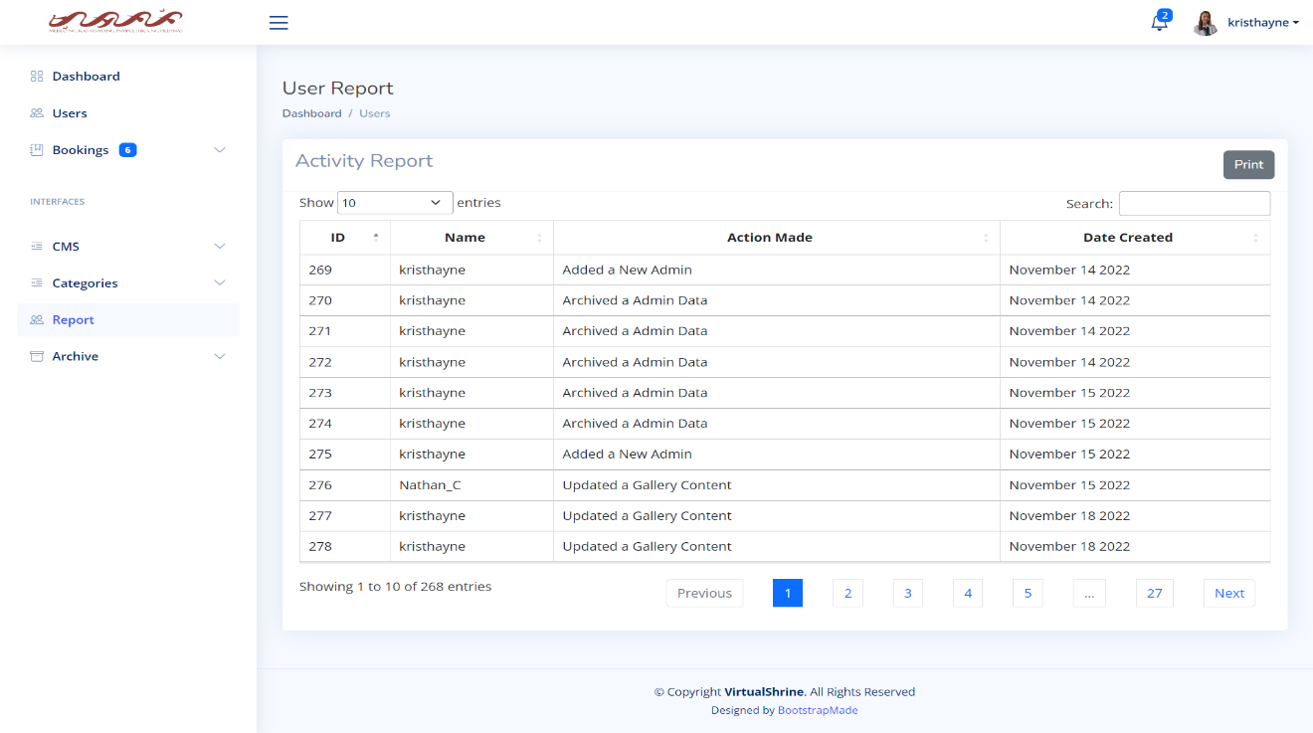

**Figure 85.** **Activity Report**

**Printing Report**

Figure 86 shows the printing report. This will help the admin to have a hard copy of the data when it needs to be submitted to the museum for the documentation.

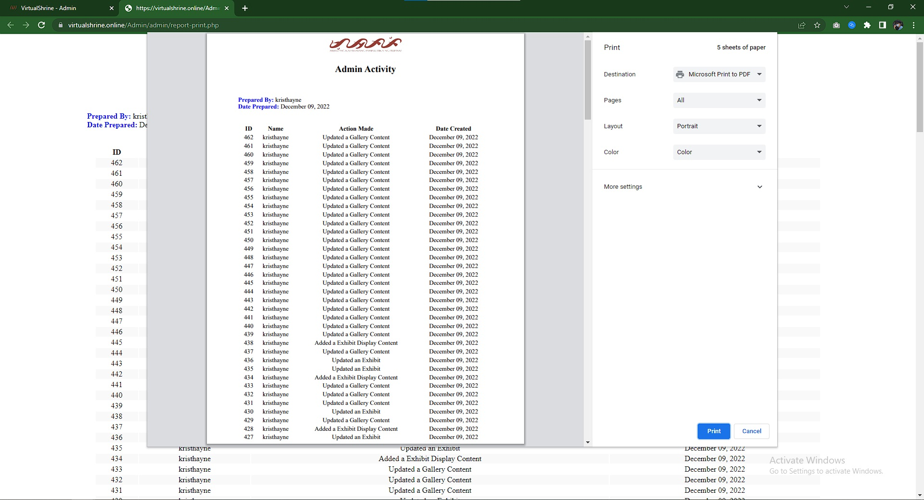

**Figure 86. Printing Report**

* 1. **Booking Confirmation through email after reservation**

**Email from the Administration**

Figure 87 displays the confirmation of booking reservation. This confirmation email will automatically be sent to the email provided by the visitor during the booking process if the administrator approves their booking. The email includes the booking information, reminders, and the link for cancellation and rescheduling of booking.



**Figure 87. Email from the Administration**

**Part III. Software Quality Evaluation of the VirtualShrine: An Interactive Museum Website for Casa Real Shrine**

It is comprised of several tables that illustrate how well the VirtualShrine: An Interactive Museum Website performs. Table 3 shows the *Functional Suitability* criterion; Table 4 shows the *Performance Efficiency* criterion; Table 5 shows the *Usability* criterion; Table 6 shows the *Reliability* criterion; and Table 7 shows the *Portability* criterion. In addition, a table that presents the total number of respondents and a five-score Likert scale are also included. The developed application was assessed in terms of functional suitability, performance efficiency, usability, reliability, and portability using the ISO/IEC 25010:2011 or the Square - System and Software Quality Models.

The respondents of this study are five (5) IT Professionals that have proven extensive knowledge or working in the field of Information Technology, five (5) Faculty Members from the College of Information and Communications Technology, twelve (12) students, ten (10) Local Tourist, ten (10) Foreign Tourist and three (3) Casa Real Shrine Museum Staff.

|  |  |  |
| --- | --- | --- |
| **Total Number of Respondents** | | |
| **Evaluators** | **Frequency** | **Percentage (%)** |
| IT Professionals | 5 | 11% |
| CICT Faculty | 5 | 11% |
| Casa Real Shrine Museum Staff | 3 | 7% |
| Student | 12 | 27% |
| Local Tourist | 10 | 22% |
| Foreign Tourist | 10 | 22% |
| **TOTAL** | **45** | **100%** |

**Table 6**

The evaluation procedure used a five-score scale which is 1 for Strongly Disagree, 2 for Disagree, 3 for Moderately Agree, 4 for Agree, and 5 for Strongly Agree. The fives-core rating with its frequencies was collected from 45 respondents and the computed mean.

|  |  |  |
| --- | --- | --- |
| **5-Score Likert Scale** | | |
| **Scale** | **Range** | **Descriptive Interpretation** |
| 5 | 4.60-5.00 | Strongly Agree |
| 4 | 3.60-4.59 | Agree |
| 3 | 2.60-3.59 | Moderately Agree |
| 2 | 1.60-2.59 | Disagree |
| 1 | 0-1.59 | Strongly Disagree |

**Table 7**

Table 8. Show Under the functional suitability sub characteristics, the functional completeness has a total mean of 4.64, interpreted as Strongly Agree, proved the developed website is capable to attain specified user objectives. Functional correctness has a total mean of 4.62, interpreted as Strongly Agree and still has a high acceptance rating from the respondents. And lastly, functional appropriateness has a total mean of 4.64, interpreted as Strongly Agree proved the developed website has an efficient and effective way of accomplishing all the specified tasks. Based on all the computed mean 4.64 is the final interpretation of the respondents it means that they are strongly agree that the website is with the functionality of the developed web portal.

|  |  |  |  |  |  |  |  |  |
| --- | --- | --- | --- | --- | --- | --- | --- | --- |
| Frequency Distribution and Descriptive Measures in the Evaluation of the Developed Website in terms of Functional Suitability | | | | | | | | |
| ***No.*** | ***Characteristics*** | ***5*** | ***4*** | ***3*** | ***2*** | ***1*** | ***Mean*** | ***Descriptive Interpretation*** |
| 1 | ***Functional Completeness.*** The system functions according to its intended purpose. | **32** | **10** | **3** | **0** | **0** | **4.64** | Strongly Agree |
| 2 | ***Functional Correctness***. The system gives the exact output on each input per module. | **30** | **13** | **2** | **0** | **0** | **4.62** | Strongly Agree |
| 3 | ***Functional Appropriateness***. The system functions like any standard system entirely. | **32** | **10** | **3** | **0** | **0** | **4.64** | Strongly Agree |
|  | | **Weighted Mean** | | | | | **4.64** | **Strongly Agree** |

*4.60 - 5.00 Strongly Agree, 3.60 - 4.59 Agree, 2.60 - 3.59 Moderately Agree, 1.60 - 2.59 Disagree,0 - 1.59 Strongly Disagree*

**Table 8**

Table 9. Based on the information provided, it appears that the VirtualShrine website has performed well in terms of its time behavior, resource utilization, capacity, and system accuracy. The respondents strongly agreed with the performance efficiency of the website, as indicated by the weighted mean of 4.65. This suggests that the website was able to meet the expected results in a short amount of time and uses a small proportion of resources when in use. Overall, it seems that the VirtualShrine website is efficient in its performance.

|  |  |  |  |  |  |  |  |  |
| --- | --- | --- | --- | --- | --- | --- | --- | --- |
| Frequency Distribution and Descriptive Measures in the Evaluation of the Developed Website in terms of Performance Efficiency | | | | | | | | |
| ***No.*** | ***Characteristics*** | ***5*** | ***4*** | ***3*** | ***2*** | ***1*** | ***Mean*** | ***Descriptive Interpretation*** |
| 1 | ***Time-Behavior.*** The system's response and processing times, as well as its throughput rates, carry out its intended tasks and adhere to the specifications. | **34** | **7** | **3** | **1** | **0** | **4.64** | Strongly Agree |
| 2 | ***Resource Utilization.*** The amount and kind of resources used by the system meet the criteria. | **31** | **11** | **3** | **0** | **0** | **4.62** | Strongly Agree |
| 3 | ***Capacity.*** The system manages time efficiently and effectively. | **32** | **11** | **2** | **0** | **0** | **4.67** | Strongly Agree |
| 4 | ***System accuracy.*** The system accurately presents the output at the maximum level. | **33** | **9** | **3** | **0** | **0** | **4.67** | Strongly Agree |
|  | | **Weighted Mean** | | | | | **4.65** | **Strongly Agree** |

*4.60 - 5.00 Strongly Agree, 3.60 - 4.59 Agree, 2.60 - 3.59 Moderately Agree, 1.60 - 2.59 Disagree,0 - 1.59 Strongly Disagree*

**Table 9**

Table 10. Shows the items used in determining the compatibility of the developed website. Which is categorized by Co-Existence, Interoperability and Flexibility. The Compatibility have a total means of 4.96 which interpreted as Strongly Agree. This shows that the website Virtual Shrine has complete features when it comes to compatibility.

|  |  |  |  |  |  |  |  |  |
| --- | --- | --- | --- | --- | --- | --- | --- | --- |
| Frequency Distribution and Descriptive Measures in the Evaluation of the Developed Website in terms of Compatibility | | | | | | | | |
| ***No.*** | ***Characteristics*** | ***5*** | ***4*** | ***3*** | ***2*** | ***1*** | ***Mean*** | ***Descriptive Interpretation*** |
| 1 | ***Co-Existence.*** The system can efficiently perform its required functions while sharing a familiar environment and resources with other systems, with no negative influence on any other method. | **34** | **9** | **1** | **1** | **0** | **4.69** | Strongly Agree |
| 2 | ***Interoperability.*** The system can exchange information and utilize data that has been exchanged between two or more platforms. | **30** | **12** | **3** | **0** | **0** | **4.6** | Agree |
| 3 | ***Flexibility.*** The system can be accessed on both phone and computer browsers. | **35** | **9** | **1** | **0** | **0** | **4.76** | Strongly Agree |
|  | | **Weighted Mean** | | | | | **4.69** | **Strongly Agree** |

*4.60 - 5.00 Strongly Agree, 3.60 - 4.59 Agree, 2.60 - 3.59 Moderately Agree, 1.60 - 2.59 Disagree,0 - 1.59 Strongly Disagree*

**Table 10**

Table 11. Shows the items used in determining the usability of the developed website. Which is categorized by User-Friendly, Acceptability Recognizability, System Utility and Operability. The Usability have a total means of 4.71 which interpreted as Strongly Agree. This shows that the website Virtual Shrine has complete features when it comes to usability.

|  |  |  |  |  |  |  |  |  |
| --- | --- | --- | --- | --- | --- | --- | --- | --- |
| Frequency Distribution and Descriptive Measures in the Evaluation of the Developed Website in terms of Usability | | | | | | | | |
| ***No.*** | ***Characteristics*** | ***5*** | ***4*** | ***3*** | ***2*** | ***1*** | ***Mean*** | ***Descriptive Interpretation*** |
| 1 | ***User friendly****. The design of the system is easy to understand and use.* | **32** | **10** | **3** | **0** | **0** | **4.64** | Strongly Agree |
| 2 | ***Acceptability Recognizability.*** *Users are able to determine whether the system is suitable for their requirements.* | **33** | **11** | **1** | **0** | **0** | **4.71** | Strongly Agree |
| 3 | ***System Utility.*** *The system can generate reports that can be viewed online (and can be download).* | **32** | **10** | **3** | **0** | **0** | **4.64** | Strongly Agree |
| 4 | ***Operability.*** *The system is simple to use, navigate.* | **38** | **7** | **0** | **0** | **0** | **4.84** | Strongly Agree |
|  | | **Weighted Mean** | | | | | **4.71** | **Strongly Agree** |

*4.60 - 5.00 Strongly Agree, 3.60 - 4.59 Agree, 2.60 - 3.59 Moderately Agree, 1.60 - 2.59 Disagree,0 - 1.59 Strongly Disagree*

**Table 11**

Table 12. Shows the items used to determining the reliability of the developed website by means of Maturity, Availability, Fault Tolerance, and Recoverability. The total mean of reliability that comes from the respondents is 4.68 which interpreted as Strongly Agree. This demonstrates that the created web portal is trustworthy when used normally and is accessible and fully functional when needed.

|  |  |  |  |  |  |  |  |  |
| --- | --- | --- | --- | --- | --- | --- | --- | --- |
| Frequency Distribution and Descriptive Measures in the Evaluation of the Developed Website in terms of Reliability | | | | | | | | |
| ***No.*** | ***Characteristics*** | ***5*** | ***4*** | ***3*** | ***2*** | ***1*** | ***Mean*** | ***Descriptive Interpretation*** |
| 1 | ***Maturity***. Under normal conditions, the system meets the requirements for reliability. | **33** | **10** | **2** | **0** | **0** | **4.69** | Strongly Agree |
| 2 | ***Availability.*** The system is operational and accessible when required for use. | **35** | **7** | **3** | **0** | **0** | **4.71** | Strongly Agree |
| 3 | ***Fault Tolerance.*** Despite the presence of hardware or software faults, the system or its components function as planned. | **30** | **14** | **1** | **0** | **0** | **4.64** | Strongly Agree |
| 4 | ***Recoverability.*** In an interruption or failure, the system can immediately recover the affected data and restore the system to its desired state. | **33** | **9** | **3** | **0** | **0** | **4.67** | Strongly Agree |
|  | | **Weighted Mean** | | | | | **4.68** | **Strongly Agree** |

*4.60 - 5.00 Strongly Agree, 3.60 - 4.59 Agree, 2.60 - 3.59 Moderately Agree, 1.60 - 2.59 Disagree,0 - 1.59 Strongly Disagree*

**Table 12**

Table 13. Shows the items used in determining the security of the developed website. Which is categorized by Confidentiality, Accountability, and Integrity. The Security have a total mean of 4.78 that comes from the respondents which interpreted as Strongly Agree. The system makes sure the data are secure, prohibits unauthorized users from accessing and changing the data, and saves auditable logs that demonstrate each activity was made.

|  |  |  |  |  |  |  |  |  |
| --- | --- | --- | --- | --- | --- | --- | --- | --- |
| Frequency Distribution and Descriptive Measures in the Evaluation of the Developed Website in terms of Security | | | | | | | | |
| ***No.*** | ***Characteristics*** | ***5*** | ***4*** | ***3*** | ***2*** | ***1*** | ***Mean*** | ***Descriptive Interpretation*** |
| **1** | ***Confidentiality.*** The system guarantees that the data is only available to those granted access. | **38** | **6** | **1** | **0** | **0** | **4.82** | Strongly Agree |
| **2** | ***Accountability.*** The actions of an entity can be traced uniquely by the system to the entity. | **37** | **7** | **1** | **0** | **0** | **4.8** | Strongly Agree |
| **3** | **Integrity**. The system prevents unauthorized access to, or modification of data. | **33** | **11** | **1** | **0** | **0** | **4.71** | Strongly Agree |
|  | | **Weighted Mean** | | | | | **4.78** | **Strongly Agree** |

*4.60 - 5.00 Strongly Agree, 3.60 - 4.59 Agree, 2.60 - 3.59 Moderately Agree, 1.60 - 2.59 Disagree,0 - 1.59 Strongly Disagree*

**Table 13**

Table 14 shows the items used in determining the maintainability of the developed system, which is categorized by Modularity, Modifiability, Testability, and Analyzability. The total computed mean for the maintainability is 4.79 which interpreted as Strongly Agree. It demonstrates the system's adaptability to various hardware, software, and other operational or usage scenarios. Mobile devices like smartphones, tablets, and PCs can all access the designed system online.

|  |  |  |  |  |  |  |  |  |
| --- | --- | --- | --- | --- | --- | --- | --- | --- |
| Frequency Distribution and Descriptive Measures in the Evaluation of the Developed Website in terms of Maintainability | | | | | | | | |
| ***No.*** | ***Characteristics*** | ***5*** | ***4*** | ***3*** | ***2*** | ***1*** | ***Mean*** | ***Descriptive Interpretation*** |
| **1** | ***Modularity.*** Because the system is made up of distinct parts, altering one has little to no impact on the others. | **39** | **6** | **0** | **0** | **0** | **4.87** | Strongly Agree |
| **2** | ***Modifiability***. The system allows updating different user records through level of security. | **35** | **9** | **1** | **0** | **0** | **4.76** | Strongly Agree |
| **3** | ***Testability***. It is clear that the application is effective and efficient. For the product, test criteria can be set, and tests can be run to see if the criteria have been met. | **35** | **9** | **1** | **0** | **0** | **4.76** | Strongly Agree |
| **4** | ***Analyzability.*** The system works well and efficiently. One can evaluate the effects of a planned modification to a system or product on one or more of its components. | **35** | **10** | **0** | **0** | **0** | **4.78** | Strongly Agree |
|  | | **Weighted Mean** | | | | | **4.79** | **Strongly Agree** |

*4.60 - 5.00 Strongly Agree, 3.60 - 4.59 Agree, 2.60 - 3.59 Moderately Agree, 1.60 - 2.59 Disagree,0 - 1.59 Strongly Disagree*

**Table 14**

Table 15 shows the item used in determining the portability of the developed system, which is categorized by Adaptability. Out of 45 respondents 38 is strongly agree and 7 is agree for the adaptability of the website. The portability has a total mean of 4.84 which interpreted as Strongly Agree. This means that the respondents strongly agree with portability of the website Virtual Shrine.

|  |  |  |  |  |  |  |  |  |
| --- | --- | --- | --- | --- | --- | --- | --- | --- |
| Frequency Distribution and Descriptive Measures in the Evaluation of the Developed Website in terms of Portability | | | | | | | | |
| ***No.*** | ***Characteristics*** | ***5*** | ***4*** | ***3*** | ***2*** | ***1*** | ***Mean*** | ***Descriptive Interpretation*** |
| **1** | ***Adaptability.*** The system can effectively and efficiently be adapted for different evolving hardware, software, or other operational or usage environments. | **38** | **7** | **0** | **0** | **0** | **4.84** | Strongly Agree |
|  | | **Weighted Mean** | | | | | **4.84** | **Strongly Agree** |

*4.60 - 5.00 Strongly Agree, 3.60 - 4.59 Agree, 2.60 - 3.59 Moderately Agree, 1.60 - 2.59 Disagree,0 - 1.59 Strongly Disagree*

**Table 15**

Functional Suitability registered a computed mean of 4.64 with a descriptive interpretation as “Strongly Agree”. Performance Efficiency on the other hand acquired 4.65 which is also interpreted as “Strongly Agree”. Compatibility registered a computed mean of 4.69 with a descriptive interpretation as “Strongly Agree”. Usability registered a computed mean 4.71 with a descriptive interpretation as “Strongly Agree”. Reliability registered a computed mean 4.68 with a descriptive interpretation as “Strongly Agree”. Security registered a computed mean 4.78 with a descriptive interpretation as “Strongly Agree”. Maintainability registered a computed mean 4.79 with a descriptive interpretation as “Strongly Agree”. Portability acquired 4.84 which garnered the highest mean among the other criteria.

|  |  |  |
| --- | --- | --- |
| **Software Criteria** | **Computed Mean** | **Descriptive Interpretation** |
| **1. Functional Suitability** | **4.64** | **Strongly Agree** |
| **2. Performance Efficiency** | **4.65** | **Strongly Agree** |
| **3. Compatibility** | **4.69** | **Strongly Agree** |
| **4. Usability** | **4.71** | **Strongly Agree** |
| **5. Reliability** | **4.68** | **Strongly Agree** |
| **6. Security** | **4.78** | **Strongly Agree** |
| **7. Maintainability** | **4.79** | **Strongly Agree** |
| **8. Portability** | **4.84** | **Strongly Agree** |
| **Overall Mean** | **4.72** | **Strongly Agree** |

**Table 16**